Foundations of Robotics - Control Systems

**Open and close loop controls**

In order to perform a task autonomously, the robot needs a control algorithm.

**Open Loop Control algorithm:**

* Allows the sending of instructions to the actuators (e.g. power of the wheel’s motors) without actually observing the outcome of those instructions.
* E.g. toaster or microwave are open loop systems.

**Close Loop Control algorithm:**

Generates instructions, or control values (u), based on the error (e), i.e. the difference between a reference value (r) and a measure (y) of the robot’s state. Also called a feedback control system

**Feedback Control: Basic Building Blocks**

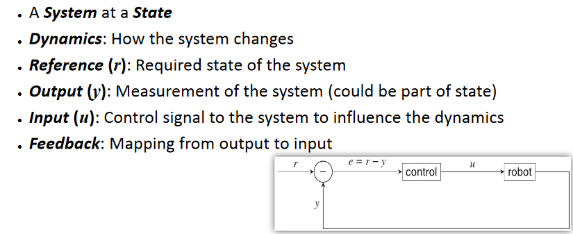

**Feedback control: Time period**

How often should one measure the robot state and set a new control value?

If it is too often i.e. the period very small, lots of computational resources may be unnecessary taken away from the robot by the control algorithm.

If too seldom, i.e. time periodvery large, the control algorithm, may act too slowly and the robot may miss the desired target.

e.g. robot approaching an object that is 1m away at 0.3 m/s

If  = 2ms then the distance travelled is 0.3 * 0.002 = 0.0006m 🡪 a waste

If  = 2s, then the distance travelled = 0.3 * 2 = 0.6 m 🡪 this results in collisions.

Ziegler –Nichols method - adjusting the gain in a PID controller to reduce the errors.

**On-Off (Bang-Bang) Controller**

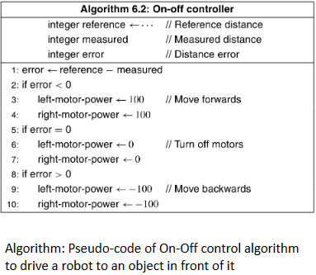Check the error at constant intervals.

If the error is not null, a fixed control value is generated depending on the sign of the error.

Very simple algorithm but also very poor performance as the robot may end up in a unstable situation.

**Example of On-Off Controller**

Consider a robot approaching an object. The robot is likely to overrun the reference distance where this reference distance

Check the error at constant intervals

If the error is not null, a fixed control value is generated depending on the sign of the error